**Jared Morell**

**HW 5**

**Generating Carrier Modulated CA Code:**

The simplified formula for generating the GPS modulated code (leaving out navigation data and Doppler frequency) is as follows:

$$x_{i}\left(t\right)=AC_{i}\left(t\right)cos⁡(2πf_{IF}t+ϕ_{i})$$

where *x* is the modulated code, *i* is the specific satellite, *A* is the amplitude, *C* is the CA code, $f_{IF}$ is the Intermediate Frequency of the receiver front end, t is time, and $ϕ_{i}$ is the phase. The Intermediate Frequency was set to 1.25 Mhz, and all other variables besides the code were input by the user. Generating carrier modulated CA code thus first required utilizing the CASamples program previously written to generate CA code for a given satellite and sample it. This could then be substituted back into the above formula, and the modulated signal would be formed. The figure below shows part of one modulated code.

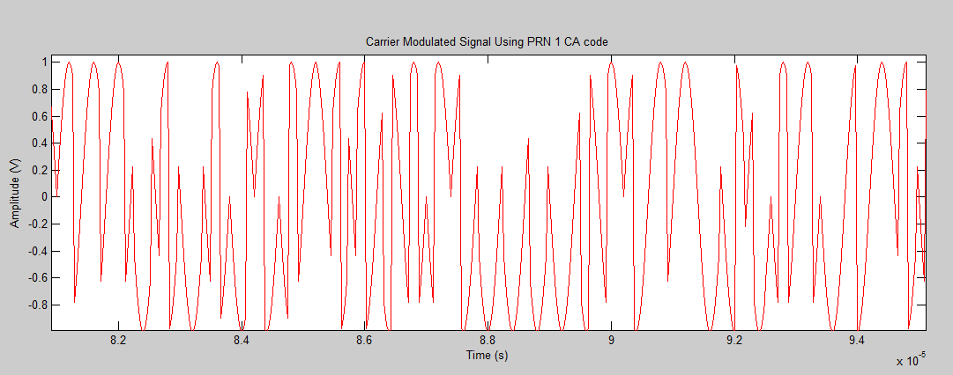

**Correlation:**

Correlation was done the same way as in HW 4. Cross-correlating two different satellites’ modulated code required shifting one signal, one index at a time, multiplying samples corresponding indices, and adding them all up. Auto-correlation was done the same way, except comparing one signal with itself. Plots of cross- and auto- correlation can be found at the end of this report.

**Power Spectrum:**

It is known that if a signal x(t) is real, its auto-correlation and power spectrum are a Fourier Transform pair:

$$S\left(f\right)=\int_{-∞}^{∞}{R\left(τ\right)e^{-j2πfτ}dτ}$$

$$R\left(τ\right)⇔S\left(f\right)$$

where *S* is the power spectrum and *R* is *x*’s auto-correlation function. FFT was then used on the auto-correlation function. Taking the magnitude of this function and setting it to a log scale, the modulated code’s power spectrum could be visualized. Below is a plow showing the power spectrum, along with the correlations. However, the power spectrum is incorrect at the moment.

